Exercise 1: Setting up a NodeJS Application
Step-by-step instructions for setting up a Node.js application from scratch. Node.js is a server-side JavaScript runtime environment that allows you to build powerful and high-performance web applications.

Step 1: Install Node.js
First, you need to install Node.js on your computer. You can download Node.js from the official website at nodejs.org.
Choose the version appropriate for your operating system (Windows, macOS, or Linux).
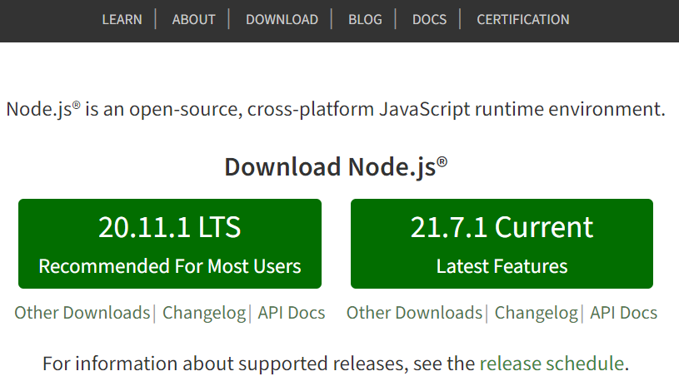
Follow the installation instructions. Once installed, you can check the installation was successful by opening a terminal or command prompt and running the following command:
node -v
npm -v
These commands will display the version of Node.js and npm (Node Package Manager) you have installed.
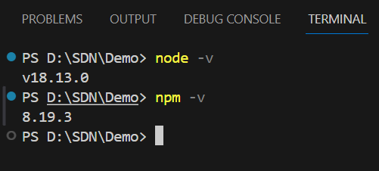

Step 2: Create a new Node.js Project
Create a new folder for your project and move into it
mkdir my-node-app
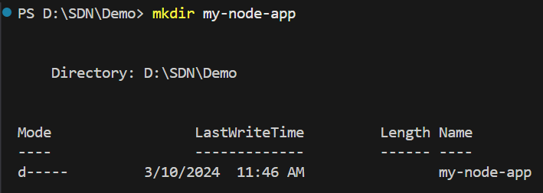
cd my-node-app

Step 3: Create A Web Server
Create server file: In the project folder, create a new file named server.js:
New-Item Server.js
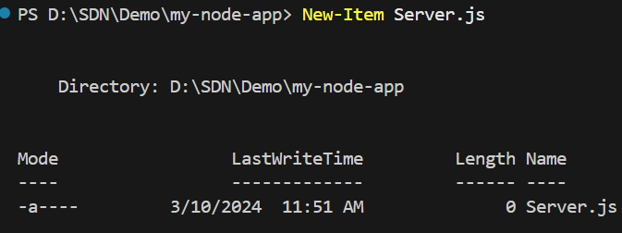
Write code for the server:
Open the server.js file in your text editor or IDE and add the following code:
const http = require('http');

const hostname = '127.0.0.1';
const port = 3000;

const server = http.createServer((req, res) => {
res.statusCode = 200;
res.setHeader('Content-Type', 'text/plain');
res.end('Hello World\n');
});

server.listen(port, hostname, () => {
console.log(`Server running at http://${hostname}:${port}/`);
});

The above code will initialize a web server using the http module available in Node.js, without using any external framework like ExpressJS.

Step 4: Run Server
Back in the terminal or command prompt, run your application using the command:
Node Server.js

Step 5: Test the Application
Open your web browser and go to http://127.0.0.1:3000. You will see the text "Hello World" displayed in your browser, proving that your web server is working.
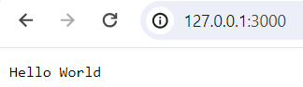
By using just the Node.js core http module, you can set up a basic web server without needing ExpressJS. However, to build more complex web applications, using frameworks like ExpressJS will make the development process easier and more efficient.

